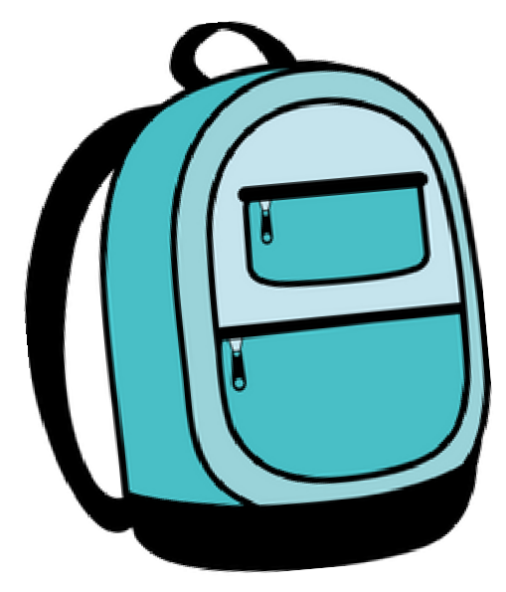

## Des Moines University Clinic

3200 Grand Avenue, Des Moines

# FREE Back-to-School Physicals!

### Choose From Two Days and Walk In

#### (No Appointment or Insurance Required)

**Noon to 5 P.M. • Tuesday, July 30, or Wednesday, July 31**

##### Translators Available.

If These Dates Won’t Work for You and You Have Insurance, Des Moines University Clinic Would Love to Be Your Medical Home! Call 515-271-1710 to Schedule.

Every Participant Will Receive a

**FREE Backpack at the Event!**

Please visit [**www.dmu.edu/event/school-physicals**](http://www.dmu.edu/event/school-physicals) for more details.

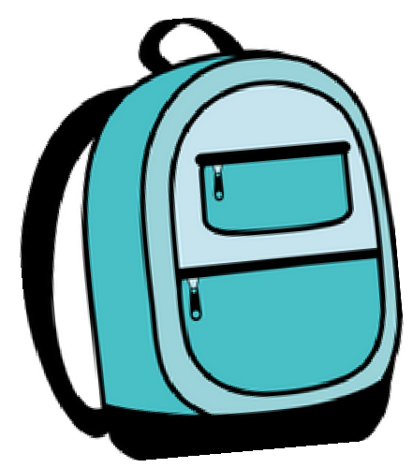

## Des Moines University Clinic

3200 Grand Avenue, Des Moines

# Fisicos Para El Regreso a Escuela Gratis!

### Elije Uno de Dos Días, y Ven.

#### (No se requiere cita o aseguranza)

**De Medio Dia a 5p.m. · Martes 30 de Julio o Miércoles 31 de Julio**

##### Interpretes disponibles

Si alguna de estas fechas no funciona para ti y tienes aseguranza, A nosotros La Clínica de Des Moines University nos encantaría ser la casa para tus necesidades médicas. Llama al (515)271- 1710 para agendar tu cita.

Cada Participante Recibira Uná

**Mochila Gratis En Este Evento!!**

Visite la pajina [**www.dmu.edu/event/school-physicals**](http://www.dmu.edu/event/school-physicals)para mas detalles.